52
CALHOUN POINT

HABITAT REHABILITATION AND ENHANCEMENT PROJECT

Pool 26
Upper Mississippi River Mile 221

Calhoun County, Illinois
St. Louis District

RESOURCE PROBLEM:

Sedimentation since 1938 has resulted in the reduction of the water surface acreage from 600 acres to 450 acres. Sedimentation has severely impacted deep water habitat. This management area is a prime site for migrating waterfowl and a prime feeding area for herons from two nearby rookeries.
PROJECT FEATURES:

- Provide a low elevation perimeter levee to substantially reduce sediment deposits from future flood events;

- Construct low elevation interior levees;

- Construct connecting ditches, swale blockages and selected deep water dredging; and

- Install gated water control structures to form four independent management units (i.e., a riverine fish unit, two wildlife units, and a combination fish/wildlife management unit).

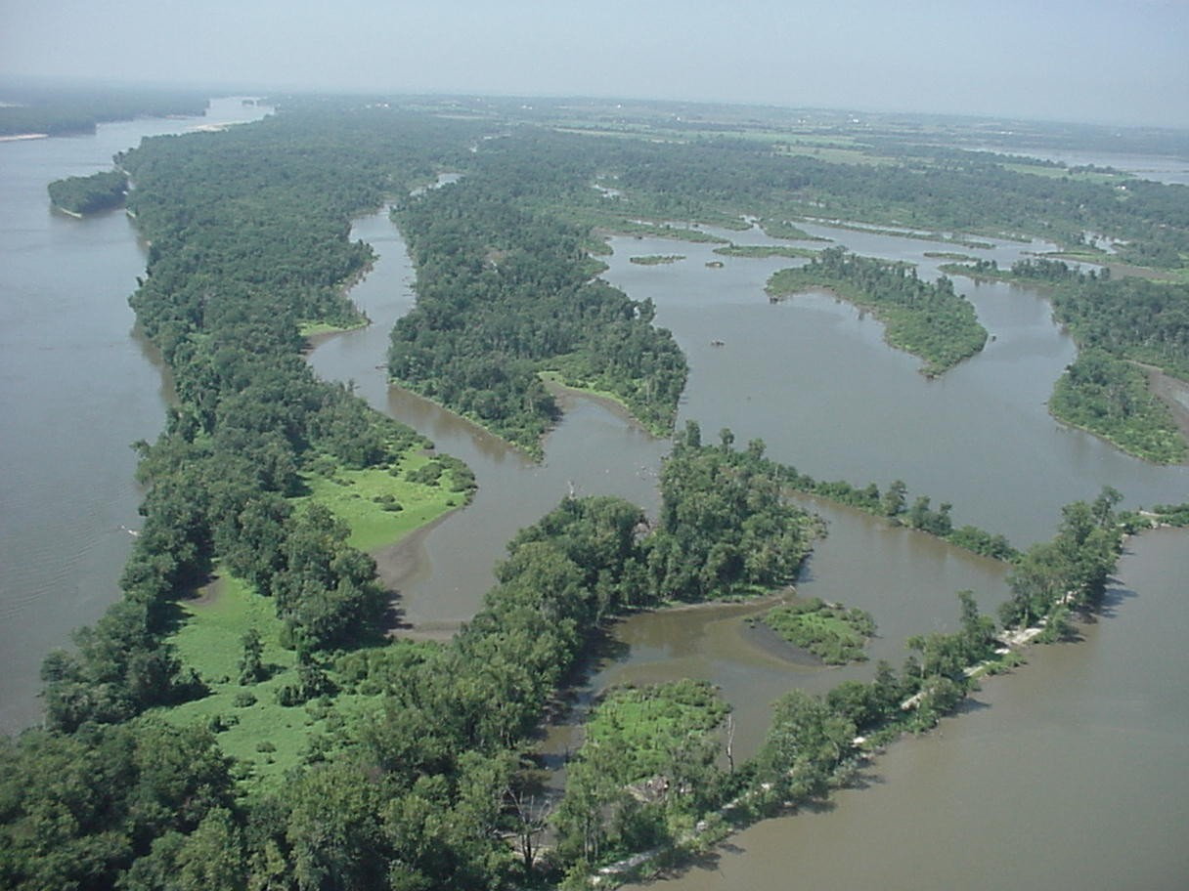

“Place photo of site in this box”

PROJECT OUTPUTS:

Rehabilitating and enhancing these wetland and aquatic habitats would provide breeding, nesting, and feeding habitats for many forms of waterfowl and other wildlife species, and would furnish productive spawning and nursery areas for riverine fishes.

FINANCIAL DATA:

General design costs are estimated at $590,000, and construction costs are estimated at $4,118,000. Annual costs for operation, maintenance, and repair are estimated at $41,700 and would be the responsibility of the non-Federal sponsor, the Illinois Department of Natural Resources.

STATUS:

A construction contract for Phase I was awarded in June of 2003 with construction beginning in August.

